# Spring Boot Microservice Connected to MongoDB in EC2 Server

## Architecture

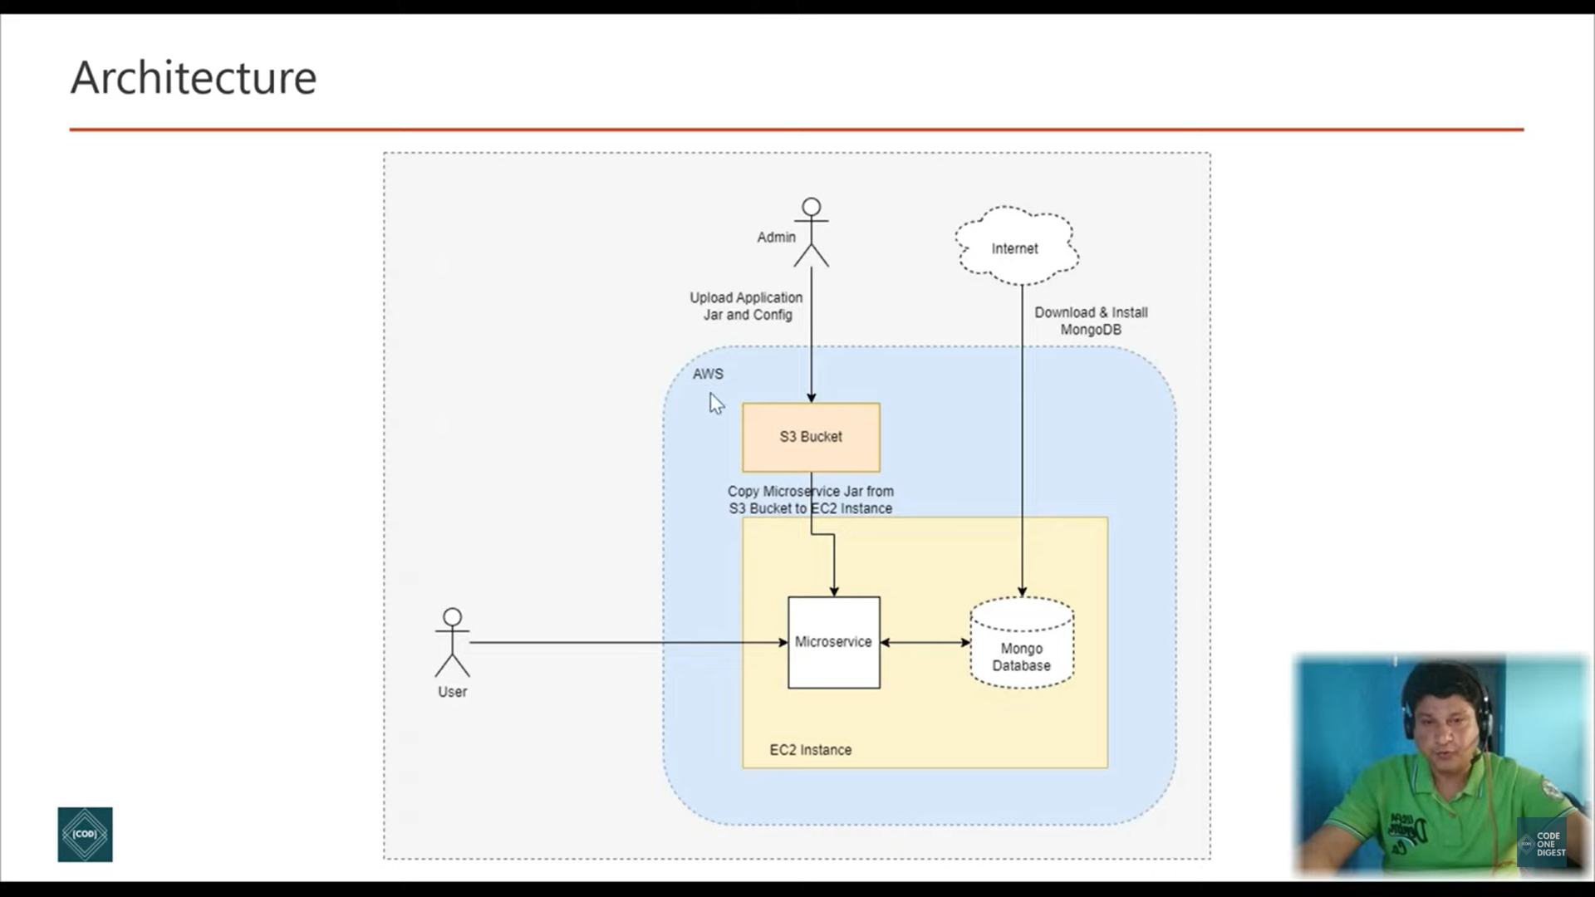

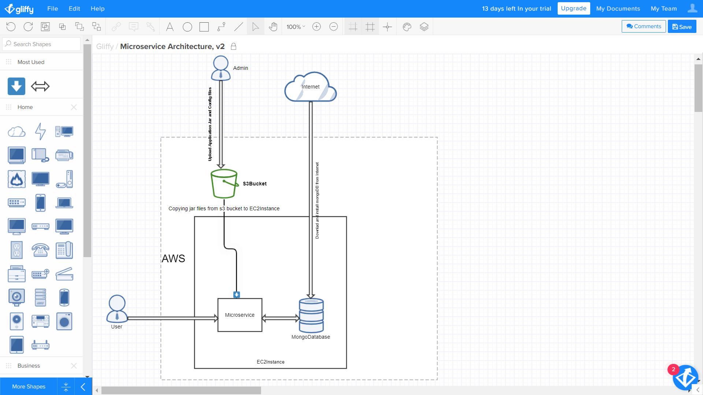

Created an ec2 instance

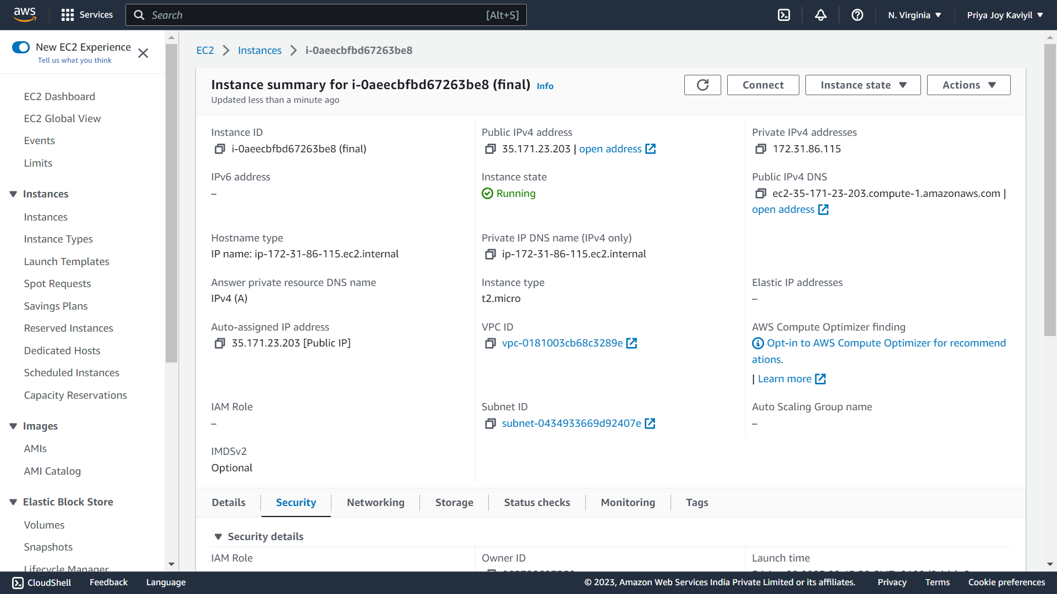

Connected to the ec2 through putty

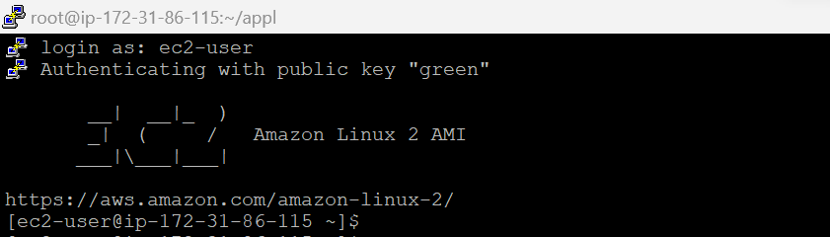

Installed mongo dB instance in the ec2

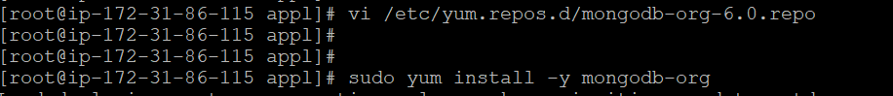

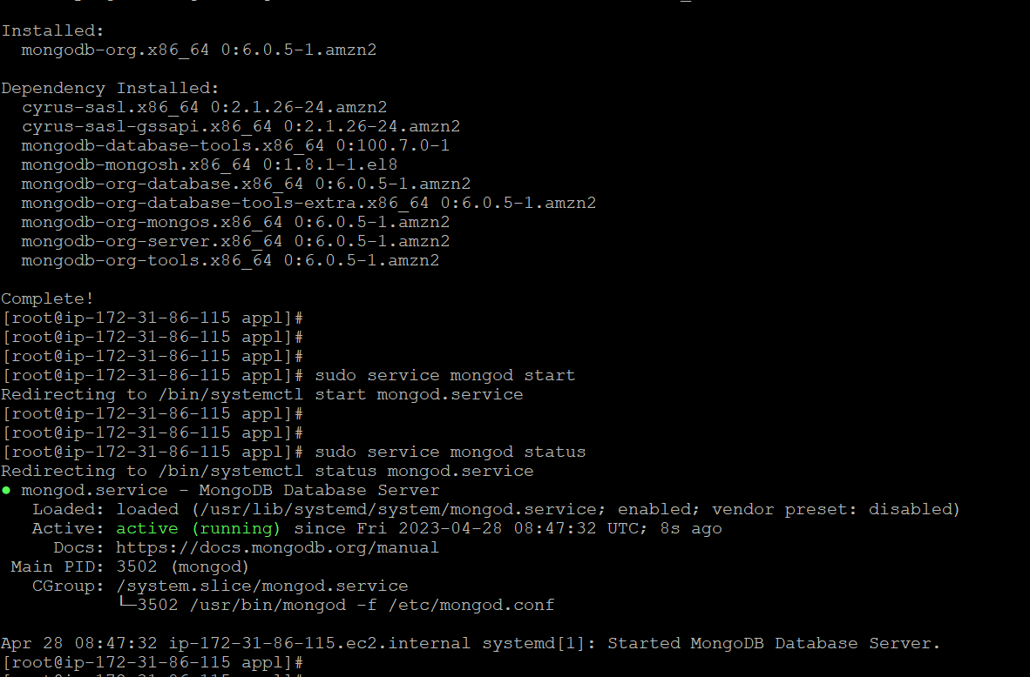

Connected to mongo db

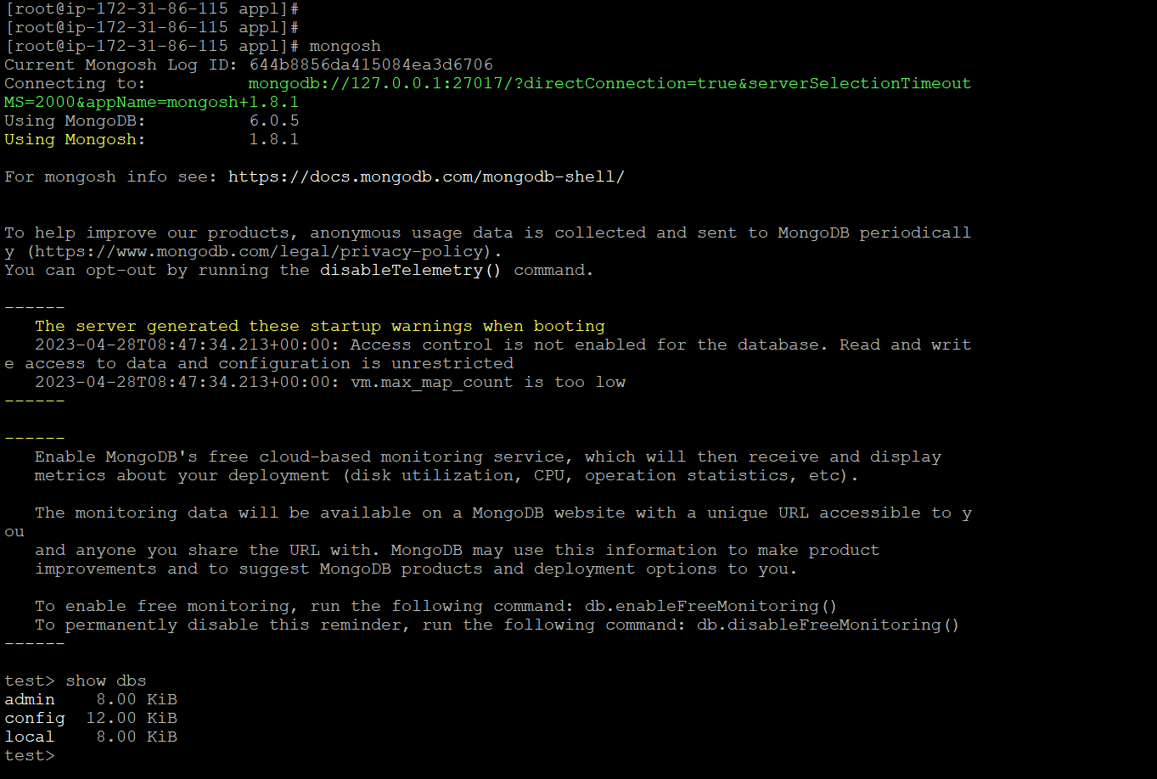

Connected mongo compass tool in local machine to mongodb in EC2 instance

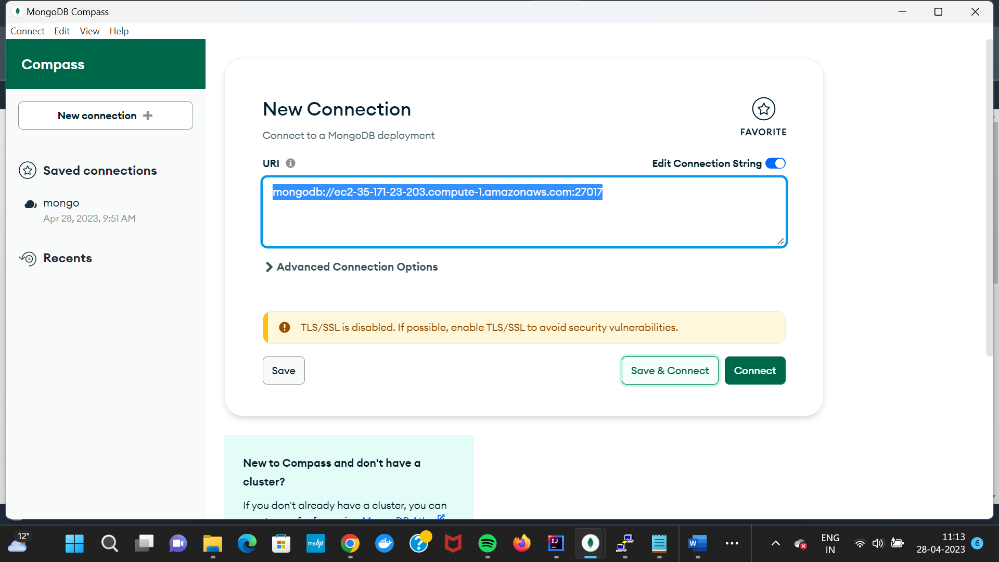

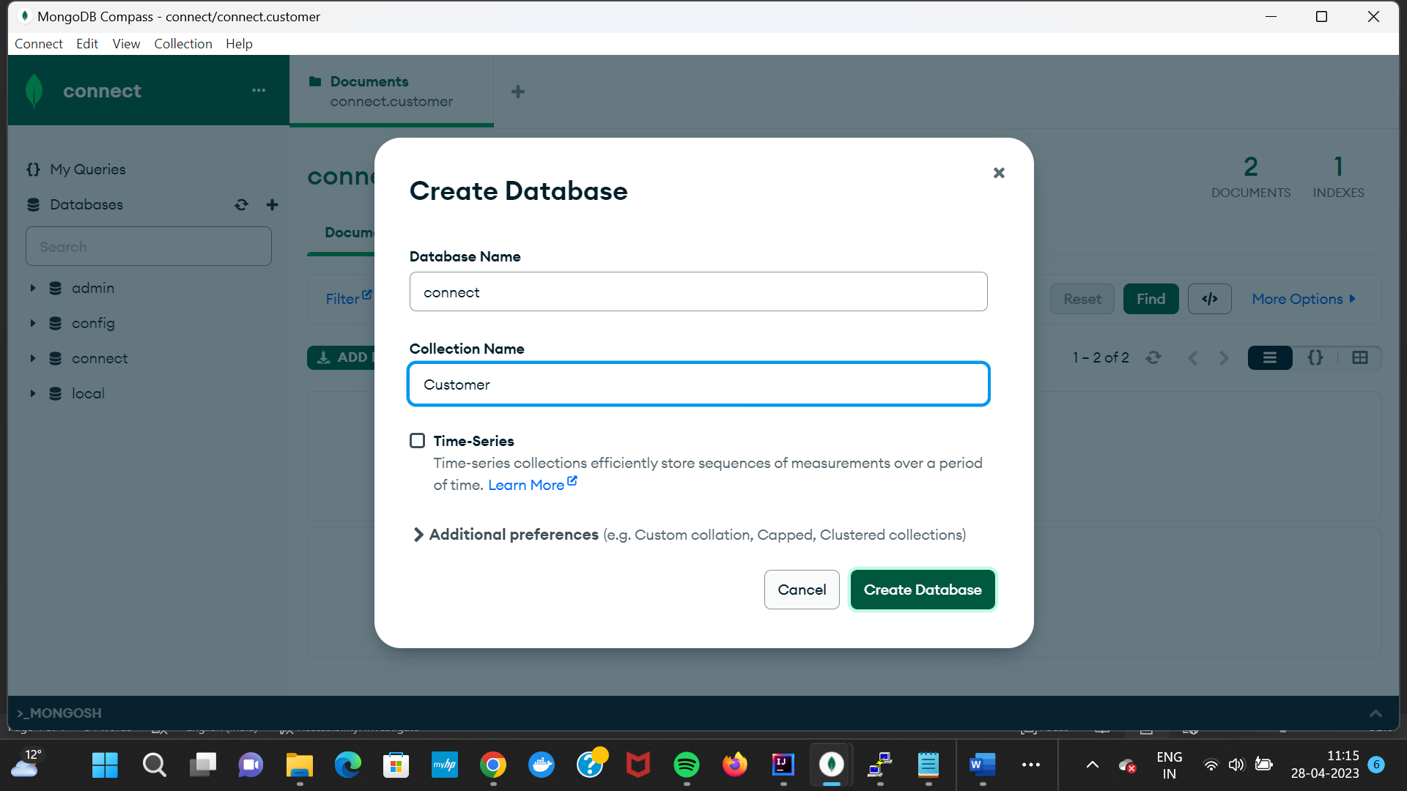

Database updated

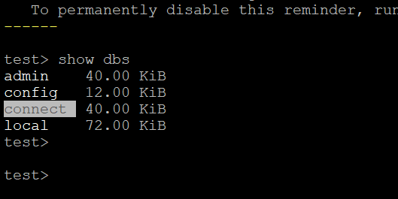

Inserted data in mongo database using mongo compass

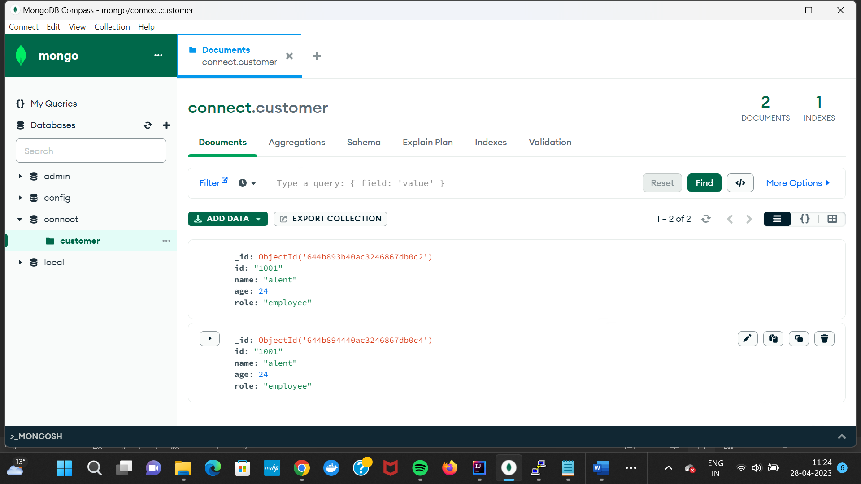

Created a Springboot Microservices. Built and compiled the project to generate jar file.

Githubrepo: <https://github.com/L00171183/ThreatModel.git>

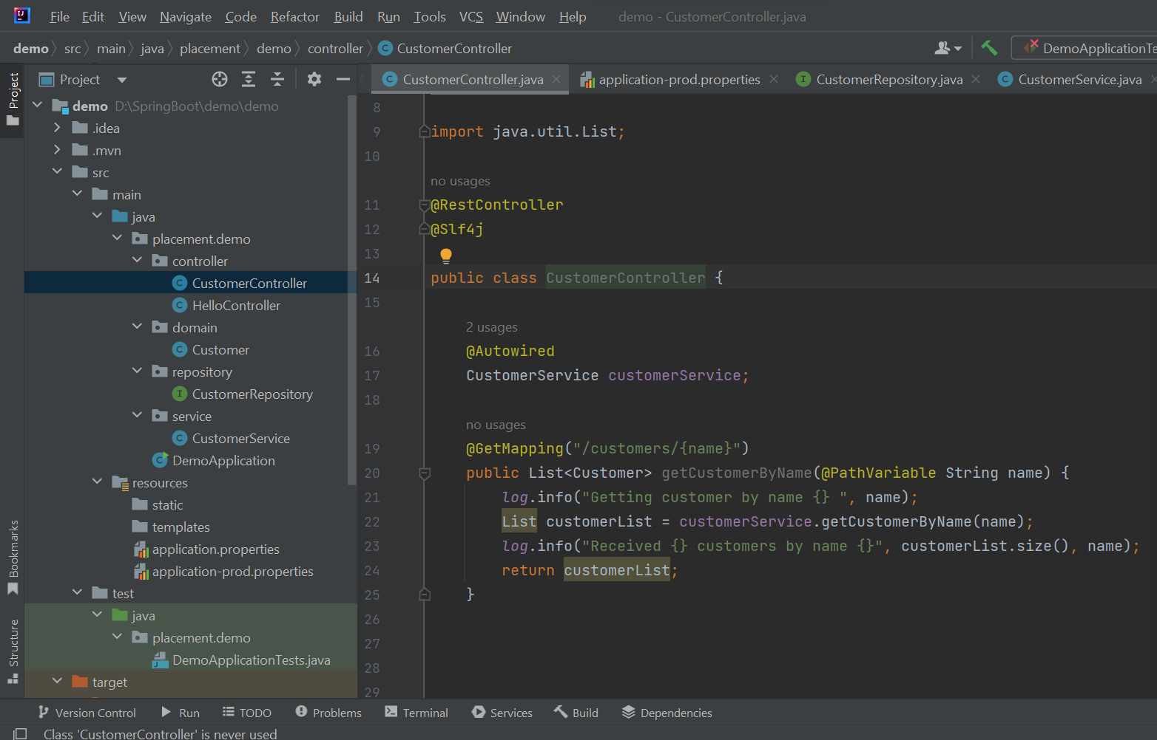

Created a S3 bucket and uploaded microservice jar

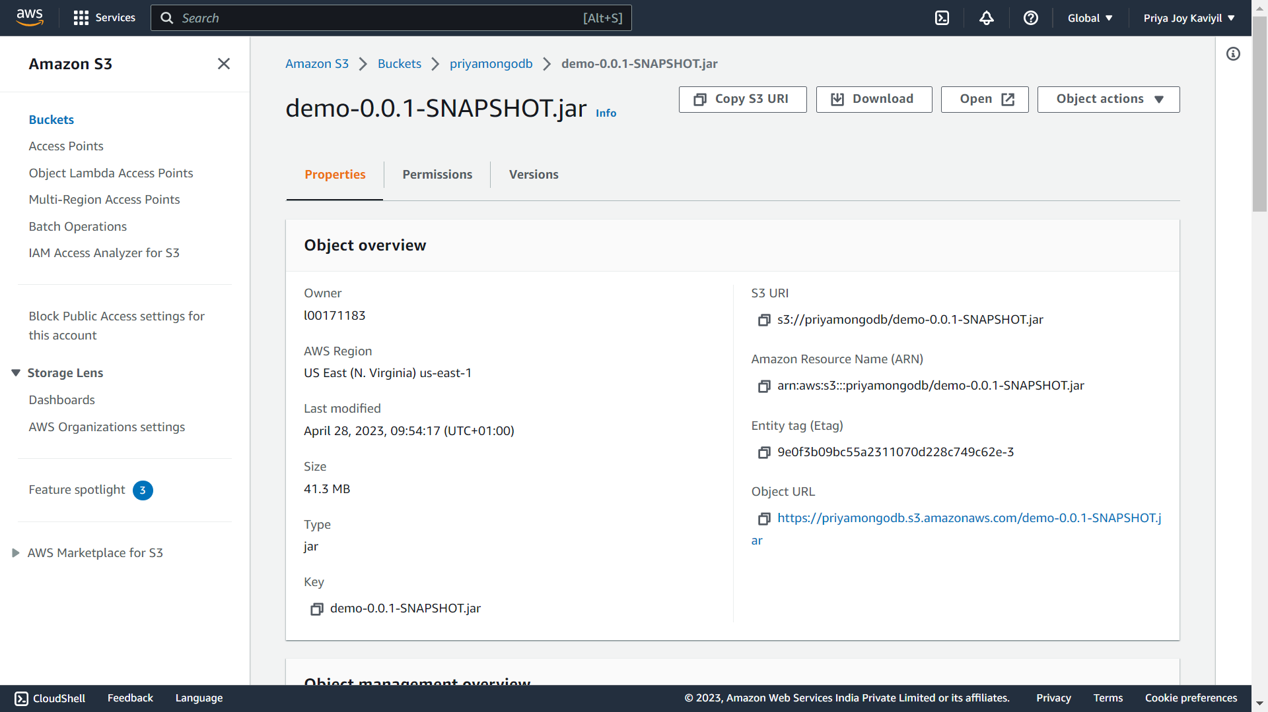

Copied microservice jar from S3 bucket to EC2 instance

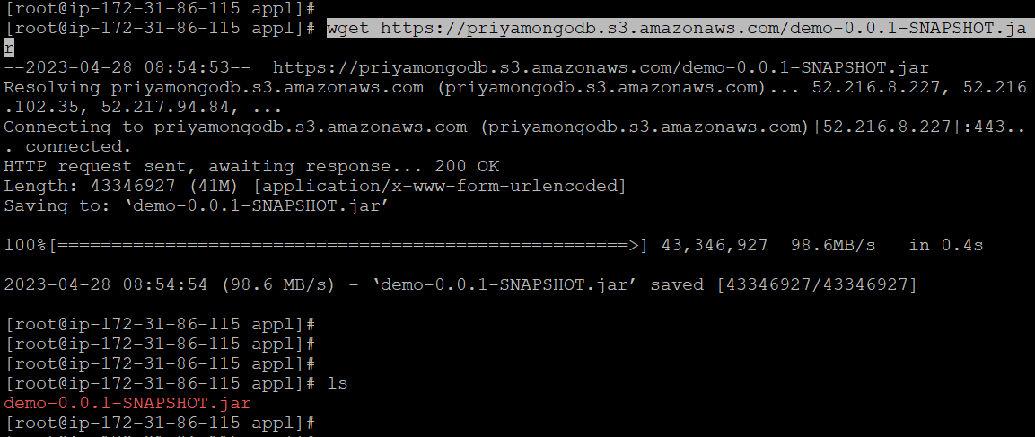

Java installed in the ec2 to run the microservice application

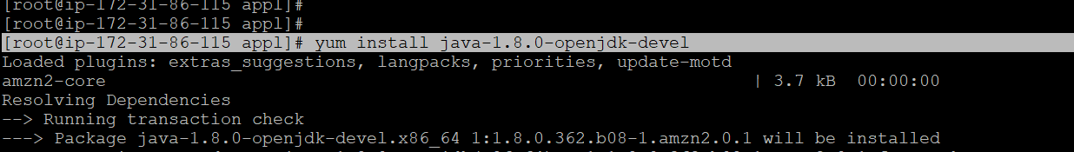

Starting the microservice application

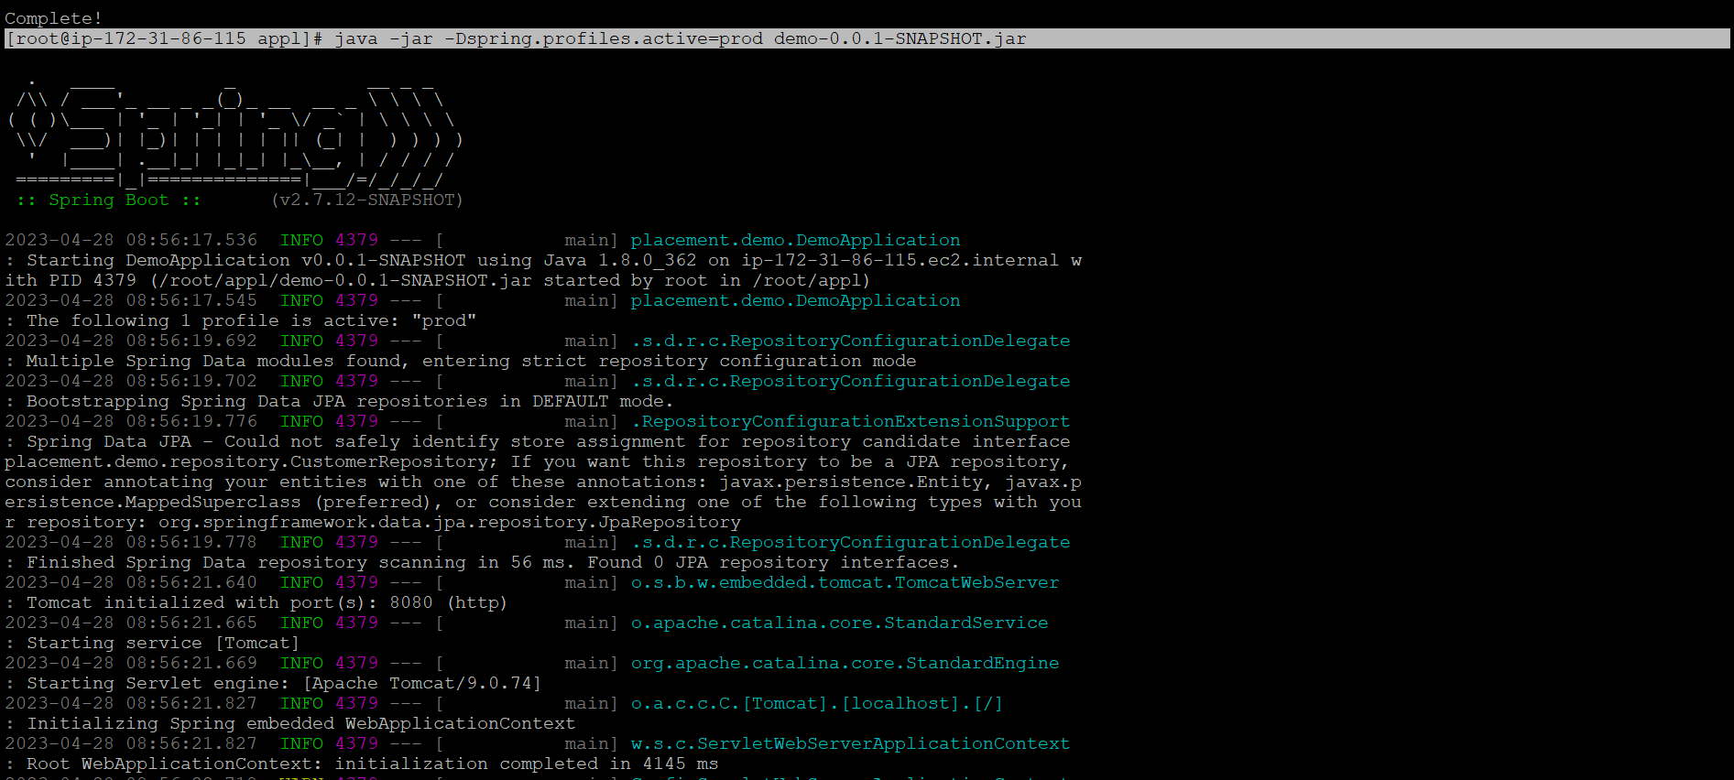

Currently working on an issue with connectivity, once this is resolved the application will run successfully.

